DATE | CODE | FACEBOOK | TWITTER
Feb 1 | Tips | DID YOU KNOW? Nearly 70% of Canada’s total private labour force are people who work for small businesses? AND that there are more than 1.1 million employer businesses in Canada. Of that number, 98% are small businesses.  Wait- there’s more!  https://blog.lendified.com/16-facts-small-businesses-canada | DID YOU KNOW? Nearly 70% of Canada’s total private labour force are people who work for small businesses? http://bit.ly/2gXNe1p
Feb 2 | News | Why the best hire might not have the perfect resume  https://www.ted.com/talks/regina_hartley_why_the_best_hire_might_not_have_the_perfect_resume | Why the best hire might not have the perfect resume http://bit.ly/1NPnCgt
Feb 3 | Client profile  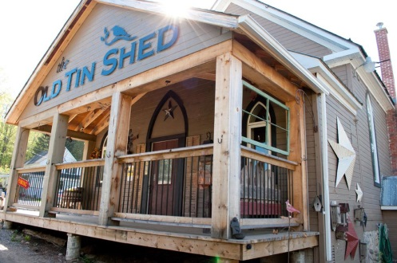 | CFDC financing helped the Old Tin Shed in Bancroft to work towards opening their new internet based store. @CommunityFuturesBancroft http://www.bancroftthisweek.com/?p=7496 | Congrats to Bancroft’s Old Tin Shed who received more than $14k from @CFDCBancroft for a new Internet-based store http://www.bancroftthisweek.com/?p=7496
Feb 6 | Reach | There is only a certain amount of time during the day to finish tasks but no matter what we do, it seems that time is never enough.  http://www.theglobeandmail.com/report-on-business/small-business/sb-managing/four-time-wasters-that-kill-your-productivity/article32700275/ | Four time wasters that kill your productivity /via @globeandmail https://tgam.ca/2fBoi12
Feb 7 | Behind the scenes  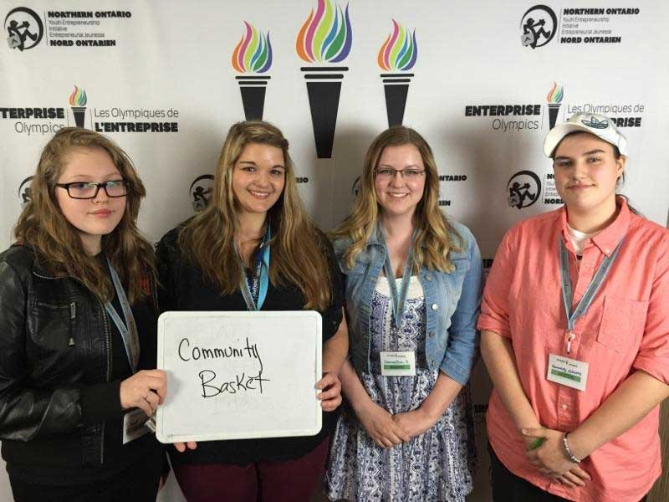 | Northern Ontario Students gain real-world experience working with CFDCs during this exclusive Business Idea Competition  http://bit.ly/2knliu7 | Northern ON Students gain real-world experience working with CFDCs during this exclusive Business Idea Competition http://bit.ly/2knliu7
Feb 8 | Promo | Do you want to take your business to the next level? CFDCs can help. Reach out today at 1-888-633-2326 or find your nearest office at https://www.cfontario.ca/find-a-local-cfdc  Est-ce que vous désirez élever votre entreprise au niveau supérieur? Contactez-nous au 1-888-633-2326 ou trouvez le bureau le plus proche au https://www.cfontario.ca/fr/trouvez-une-sadc | Want to take your business to the next level? CFDCs can help-Call today 1-888-633-2326 or find the nearest office at http://bit.ly/2js6XJh  Vous voulez élever votre entreprise au niveau supérieur? Contactez-nous 1-888-633-2326 ou trouvez votre bureau https://www.cfontario.ca/fr/trouvez-une-sadc
Feb 9 | Tips | What Will Cost Canadians More and Less in 2017 http://bit.ly/2ku75vE | What Will Cost Canadians More and Less in 2017 http://bit.ly/2ku75vE
Feb 10 | Reach | Is there still an opportunity for you to bring in business by using “traditional” marketing tools?  http://www.inc.com/jayson-demers/trying-to-get-press-coverage-for-your-small-business-here-s-how.html | Is there still an opportunity for you to bring in business by using “traditional” marketing tools?  http://on.inc.com/YPx2XP
Feb 13 | News | Come read our latest newsletter! Always worth reading, and the more you know, the farther you’ll go. https://www.cfontario.ca/view-current-newsletter  Venez voir notre bulletin actuel! La connaissance est importante et qui n’avance pas, recule. https://www.cfontario.ca/fr/vue-bulletin | Come read our latest newsletter! Always worth reading, and the more you know, the farther you’ll go. https://www.cfontario.ca/view-current-newsletter  Venez voir notre bulletin actuel! La connaissance est importante et qui n’avance pas, recule. https://www.cfontario.ca/fr/vue-bulletin
Feb 14 | Client profile | A Valley Heartland CFDC’s client is expanding… again! http://bit.ly/2jm73AI @valleycfdc @onewillwoyou | A Valley Heartland CFDC’s client is expanding… again! http://bit.ly/2jm73AI @valleycfdc @onewillwoyou
Feb 15 | Behind the scenes | CFDC volunteer board members represent, live in and care about the communities they serve. THANK YOU | CFDC volunteer board members represent, live in and care about the communities they serve. THANK YOU
Feb 16 | Promo | Community Futures is a national program helping entrepreneurs grow our economy. This short video shows you how we are different… https://www.youtube.com/watch?v=jQxUeXJ0Wb8  Le Développement des collectivités est un programme national qui aide aux entrepreneurs à faire croitre notre économie. Cette courte vidéo montre comment nous sommes différents…https://www.youtube.com/watch?v=jQxUeXJ0Wb8 | Community Futures is a national program helping entrepreneurs grow our economy. See how we are different… https://www.youtube.com/watch?v=jQxUeXJ0Wb8  Le Développement des collectivités est un programme national qui aide à faire croitre notre économie https://www.youtube.com/watch?v=jQxUeXJ0Wb8
Feb 17 | Tips | Clip art  Email marketing can be an incredibly efficient ways to market to your audience. Here are 30 tips from the pros to do it right.  http://fitsmallbusiness.com/email-marketing-best-practices/ | Email marketing can be an incredibly efficient ways to market to your audience. These 30 tips from pros should help http://bit.ly/1pO1sGM
Feb 21 | News  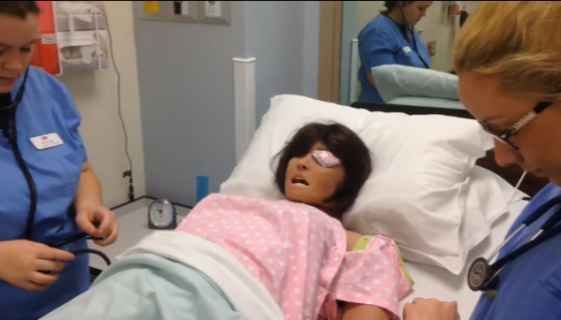 | The St Lawrence College’s new practical nursing training lab will have a lasting impact on health care thanks to an investment from the Eastern Ontario Community Futures Development Corporation Network http://www.thewhig.com/2017/01/11/simulation-offers-real-instruction | Simulation offers real instruction thanks to the Eastern Ontario Community Futures Development Corporation Network http://www.thewhig.com/2017/01/11/simulation-offers-real-instruction
Feb 22 | Client profile  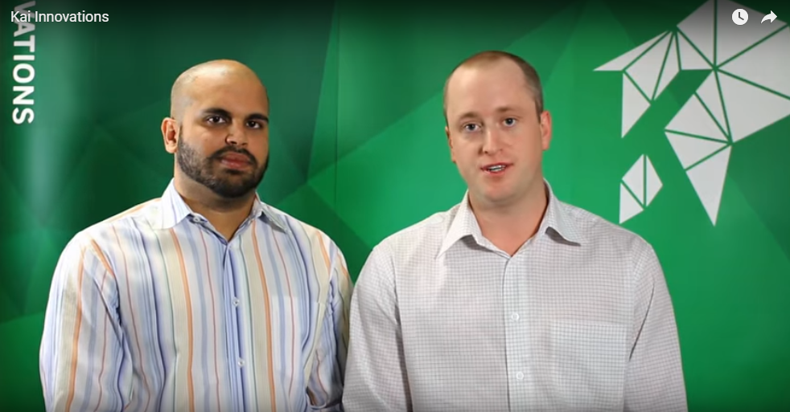 | Their CFDC helped them expand and double their workforce https://financingandstrategy.com/testimonials/ | Their CFDC helped them expand and double their workforce https://financingandstrategy.com/testimonials/
Feb 23 | Reach  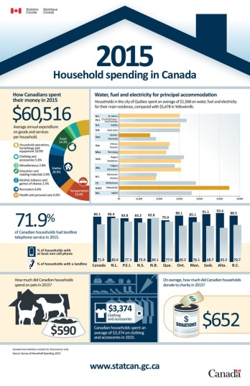 | Want to know how Canadians spent their money in 2015? Check out this infographic: http://ow.ly/XUML308pIDE | Want to know how Canadians spent their money in 2015? Check out this infographic: http://ow.ly/XUML308pIDE
Feb 24 | Behind the scenes | The Summer Company helps young people between 15 and 29 years old start and run their own summer business by providing funding, advice and services. http://bit.ly/2jdZIIa | Summer Company helps young people between 15- 29, start and run their own business by providing funding & advice http://bit.ly/2jdZIIa
Feb 27 | Promo | Calling all entrepreneurs! Need some guidance or funding to get your business going? Contact us at 888-633-2326 or find your nearest office https://www.cfontario.ca/find-a-local-cfdc  Appel aux entrepreneurs! Besoin de quelques conseils ou du financement pour lancer votre entreprise? Contactez-nous au 888-633-2326 ou trouver le bureau le plus proche https://www.cfontario.ca/fr/trouvez-une-sadc | Calling all entrepreneurs! Need help to get your business going? Call us at 888-633-2326 or find your nearest office http://bit.ly/2js6XJh  Appel aux entrepreneurs! Besoin de financement pour lancer votre entreprise? Contactez-nous au 888-633-2326 ou http://bit.ly/2kbUGvP
Feb 28 | Tips | Should I or shouldn’t I post this? http://bit.ly/2kbJxee | Should I or shouldn’t I post this? http://bit.ly/2kbJxee
Jan 30 | Reach
Jan 31 | News | It’s worth checking out these 7 reasons why being an entrepreneur and working for yourself rocks: http://ow.ly/IvFWa | It’s worth checking out these 7 reasons why being an entrepreneur and working for yourself rocks: http://ow.ly/IvFWa
CODE | TYPE
Tips | Best practices for business, tips, tricks etc. Can feature board member or client expertise.
News | CFDC media releases, news or updates, upcoming events etc.
Client profile | Share profile of CFDC client
Reach | - Inspirational Posts for entrepreneurs and small business owners  - Ask a question, call for comments.  - Poll to see about behaviour trends/opinions  - Sharing interesting articles or social media content (not by CFDC)
CFDC Behind the scenes | Posts that show what CFDC staff and volunteers and OACFDC are working on, attendance at events/meetings etc – posts that show involvement and caring about the communities in which it serves, things that offer a human face
Promo | Promotional post about the CFDC or OACFDC i.e. We serve xx businesses in the area, come learn more about XX

