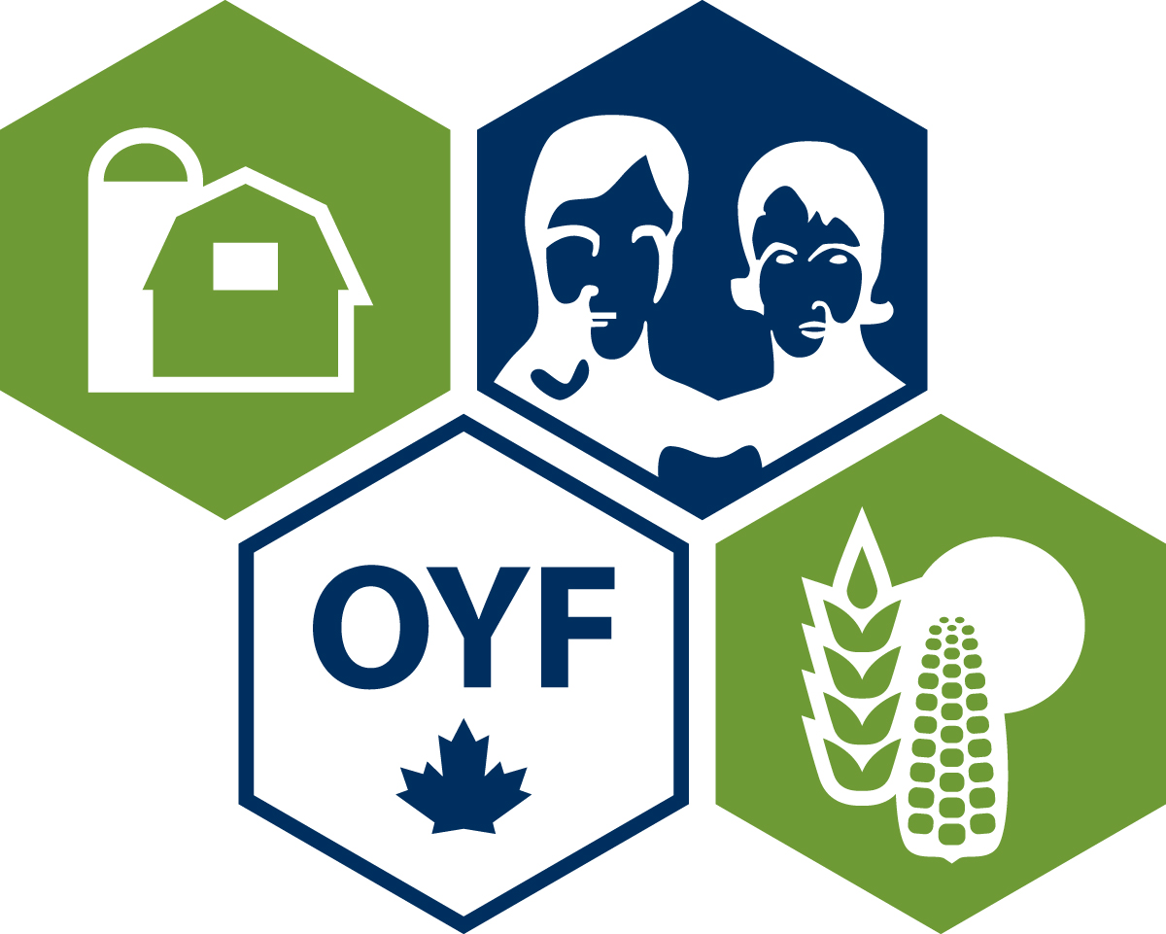
Who is Ontario’s Outstanding Young Farmer for 2013?

Here’s your chance to recognize someone with the title of the 2013 Ontario Outstanding Young Farmer. This award will be presented at the Regional Conference to be held next March 25-27 in Guelph, Ontario.

We are seeking people who contribute to the community, who seek new opportunities, and who generally are assets to Ontario’s agri-food industry.

Anyone can nominate a young farmer/farm couple/farm partnership for the award. The eligibility requirements are simply:
- Must be between the ages of 18 and 39
- Must operate a farm
- Must derive a minimum of 2/3 of their income from farming

The process is simple.
- Nominations are submitted by December 15, 2012.
- Nominees are contacted and complete an application form. Application forms are due January 31, 2013.
- A preliminary judging committee consisting of OOYF Alumni reviews the submitted application forms and contacts the top candidates. Their decision is based upon items such as the nominees progress in their agricultural career; adoption of soil, water, and energy conservation practices; financial and management practices and contribution to the well-being of the community, province, and nation.
- The top candidates then participate in an interview and presentation process at the regional event to be held in Guelph from March 25-27. The winner will be announced at the final banquet.
- The provincial winner will then compete in the National competition which is designed to recognize young farmers that exemplify excellence in their profession. The National competition for 2013 will be held in Regina from November 12-17.

If you know an outstanding young farmer, please nominate them by completing the application form (next page).

More information about OYF can be found on the website http://www.oyfontario.ca.

If you have questions about the nomination process, please contact Karen Daynard at kdaynard@sympatico.ca or (519) 836-2583.

Proudly sponsored by:




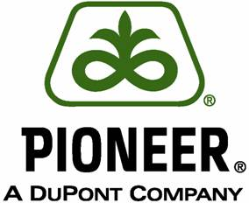

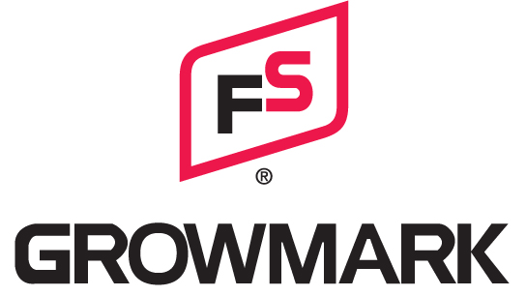

2013 Preliminary Nomination Form (Please print)

Name(s) of Nominee(s):
Address of Nominee:
County:
Age(s):
Phone (include area code):
Fax (include area code):
E-mail address:
Type of Operation:
Number of years involved in farming:
Percentage of income from farming:
Is the applicant aware of being nominated? | Yes No
Name of Nominator:
Organization (if applicable):
Signature

Nominations must be returned by Dec. 15, 2012 to:

Karen Daynard, Ontario Coordinator
6904 Paisley Road West, R.R. #7
Guelph, ON, N1H 6J4
Phone: (519) 836-2583
Fax: (519) 836-1733
Email: kdaynard@sympatico.ca



