DATE | CODE | FACEBOOK | TWITTER
Jan 3 | Tips | Applying all these New Year's resolutions throughout the year will not only make you feel better but you’ll have more energy to put into your business and make it the success you deserve! https://www.thebalance.com/top-new-year-s-resolutions-for-business-success-2947126 | Apply these resolutions to make your business the success you deserve! http://bit.ly/2fojVp7
Jan 4 | News | The Oxford Small Business Support Centre is going through a rebranding and will now be known as Community Futures Oxford. http://www.heartfm.ca/news/local-news/introducing-community-futures-oxford/ | Introducing Community Futures Oxford - 104.7 Heart FM http://www.heartfm.ca/news/local-news/introducing-community-futures-oxford/
Jan 5 | Client profile | The Grenville CFDC provided Launch Lab Inc. with an investment of $27,000. The funding supports the Business Acceleration Program which involves business acceleration consultation services and workshops delivered in Grenville by Launch Lab Inc.’s Entrepreneurs-In-Residence to local businesses and entrepreneurs.  http://bit.ly/2hjI8h9 | Client Success: The Business Acceleration program at Launch Lab Inc. in Grenville supported by the @GrenvilleCFDC http://bit.ly/2hjI8h9
Jan 6 | Reach | @PerthCFDC making a difference in St Mary’s by helping with the creation of affordable and accessible housing http://www.stratfordbeaconherald.com/2016/11/23/partnership-will-see-affordable-and-accessible-homes-built | @PerthCFDC making a difference in St Mary’s by helping with the creation of affordable and accessible housing http://bit.ly/2fSxkbV
Jan 9 | Behind the scenes | https://www.bdc.ca/en/articles-tools/change-ownership/sell-business/pages/business-valuation-whats-your-company-worth.aspx?utm_campaign=In-Business--2016-11--Regular--FR&utm_medium=email&utm_source=Eloqua  https://www.bdc.ca/fr/articles-outils/changement-proprietaire/vendre-entreprise/pages/evaluation-entreprise-que-vaut-votre-entreprise.aspx?utm_campaign=In-Business--2016-11--Regular--FR&utm_medium=email&utm_source=Eloqua | Business valuation: What's your company worth? https://www.bdc.ca/en/articles-tools/change-ownership/sell-business/pages/business-valuation-whats-your-company-worth.aspx via @@bdc_ca  Évaluation d'entreprise: Que vaut votre entreprise? https://www.bdc.ca/fr/articles-outils/changement-proprietaire/vendre-entreprise/pages/evaluation-entreprise-que-vaut-votre-entreprise.aspx via @@bdc_ca
Jan 10 | Promo | If 2017 is the year you plan on starting or growing your business; Community Futures could help. Talk to us today at 1-888-633-2326 or find your local office https://www.oacfdc.com/find-a-local-cfdc  Si 2017 est l’année que vous prévoyez démarrer ou faire croître votre entreprise ; le programme du Développement des collectivités pourraient aider. Parler avec nous aujourd’hui à 1-888-633-2326 ou trouver votre bureau local https://www.oacfdc.com/fr/trouvez-une-sadc | If 2017 is the year you start or grow your business- we could help. Call us at 888-633-2326; find your local office http://bit.ly/2hsbGvI  (with pic)  Si 2017 est l’année que vous démarrez votre entreprise, on pourra vous aider. Contactez-nous 1-888-633-2326 ou http://bit.ly/2hWRzCZ
Jan 11 | Tips | Kick-off your day with a little inspiration! | Commencer votre journée avec cette vidéo inspirante ! #success #Iwill #MotivationMondayshttps://www.youtube.com/watch?v=2wr6Jx_ffkI | Kick-off your day with a little inspiration! | Commencer votre journée avec cette vidéo inspirante! http://bit.ly/1AeKaoW
Jan12 | Reach | @NorthSimcoeCFDC is working hard at bringing high-speed Internet access to everyone in north Simcoe as soon as possible. http://www.simcoe.com/news-story/6997960-north-simcoe-business-development-group-seeks-funding-for-fibre-optic-project/ | @NorthSimcoeCFDC is working hard to bring high-speed Internet access to everyone in north Simcoe as soon as possible http://bit.ly/2hAaZkf
Jan13 | News | In an effort to show young people there are more choices than working for someone else, the Cornwall & the Counties Community Futures Development Corporation held another Be the Boss day.  http://www.standard-freeholder.com/2016/12/01/becoming-your-own-boss  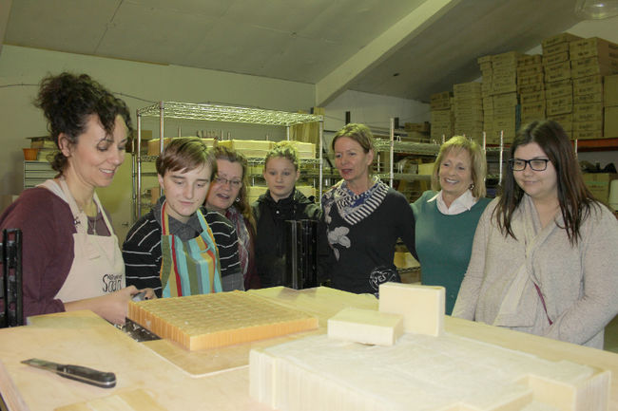 | Becoming your own boss with @CCCFDC| Cornwall Standard Freeholder http://www.standard-freeholder.com/2016/12/01/becoming-your-own-boss
Jan 16 | Client profile | You might be an entrepreneur IF…. https://www.youtube.com/watch?v=sOjeQV5pHh4 | You might be an entrepreneur IF…. https://www.youtube.com/watch?v=sOjeQV5pHh4
Jan 17 | Behind the scenes | Sound business decisions made by dedicated community volunteers.  Community Futures across Canada relies on thousands of volunteers to ensure the success of all CFDCs. 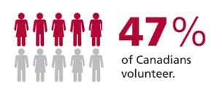  Les décisions d’affaires saines faites par des bénévoles dévoués. Les SADC partout au Canada s’appuient sur des milliers de bénévoles pour assurer le succès de toutes les SADC.  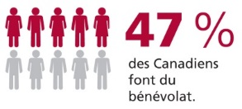 | Sound business decisions made by dedicated community volunteers. CFDCs rely on volunteers to ensure their success.  Les SADC partout au Canada s’appuient sur des milliers de bénévoles pour assurer le succès de toutes les SADC.
Jan 18 | Promo | Entrepreneurs Wanted! CFDCs offer flexible financing and business counseling. Contact your local CFDC Today! 1-888-633-2326 or find your local office at https://www.oacfdc.com/find-a-local-cfdc  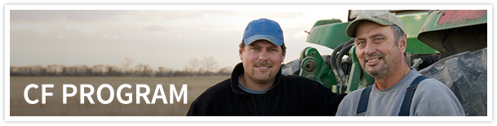  Besoin de financement commercial? Les SADC peuvent vous aider! Communiquez avec votre SADC locale dès aujourd'hui! 1-888-633-2326 ou trouver votre bureau local https://www.oacfdc.com/fr/trouvez-une-sadc | Entrepreneurs Wanted! CFDCs offer flexible financing and business counseling. Contact us 888-633-2326 or http://bit.ly/2hsbGvI  Besoin de financement commercial? Les SADC peuvent vous aider! Contactez-nous 1-888-633-2326 ou http://bit.ly/2hWRzCZ
Jan 19 | Tips | Finding it hard to connect marketing $ spent with value received? These tips might help http://www.theglobeandmail.com/report-on-business/small-business/sb-marketing/how-do-i-know-if-the-money-im-spending-on-marketing-is-worth-it/article32699859/ | Finding it hard to connect marketing $ spent with value received? These tips might help https://tgam.ca/2hDWBYu
Jan 20 | News | The 24th Annual 2017 Community Futures Conference will be held in September in London and will be hosted by the @Elgin Business Resource Centre. Elgin County- where London comes to chill!  http://bit.ly/2h6PRkV | The 24th Annual 2017 CF Ontario Conference will be held in September in London and will be hosted by @ebrc http://bit.ly/2h6PRkV
Jan 23 | Client profile | This great video created by the @WOCFDCA_funding explains exactly what a CFDC can do for you https://www.youtube.com/watch?v=04GCiDFcoi8 | This great video created by the @WOCFDCA_funding explains exactly what a CFDC can do for you https://www.youtube.com/watch?v=04GCiDFcoi8
Jan 24 | Reach | Looking to start a new business in 2017? Here’s the list of the 15 most profitable types of small businesses and their net profit margins. https://www.entrepreneur.com/slideshow/269905 | Looking to start a new business in 2017? Here’s the list of the 15 most profitable types of small businesses http://bit.ly/1TxT3TI
Jan 25 | Behind the scenes | Whether you're starting a new business, growing an established company, or adapting to the changing economic landscape, Canada Business Ontario is your business information connection. https://www.youtube.com/watch?v=xyubIKxE4sM  Vous voulez lancer une nouvelle entreprise, faire croître une entreprise existante ou restructurer une entreprise pour répondre à la nouvelle réalité économique? Peu importe, Entreprises Canada Ontario est votre source de renseignements d'ordre commercial.  https://www.youtube.com/watch?v=LkJialKAluM | Starting a business or growing an established company? Canada Business ON is your business information connection http://bit.ly/2h3ai2g  Lancez-vous une entreprise? Entreprises Canada Ontario est votre source de renseignements d'ordre commercial. http://bit.ly/2i7Ns7k
Jan 26 | Promo | Attention entrepreneurs!!!! Are you:  In rural Ontario? Looking for a loan? In need of advice?  Your local CFDC can help: http://www.oacfdc.com/?Itemid=723  Pour les entrepreneurs en Ontario rural: venez trouver votre SADC locale pour des conseils et des prêts! http://www.oacfdc.com/fr/trouvez-une-sadc | Entrepreneurs in rural Ontario, come find your local CFDC for advice and loans! http://www.oacfdc.com/?Itemid=723 (with pic)  Les entrepreneurs en Ontario rural: trouvez votre SADC locale pour des conseils et des prêts! http://bit.ly/1T5gzXl (with pic)
Jan 27 | Tips | DID YOU KNOW? Nearly 70 per cent of Canada’s total private labour force are people who work for small businesses AND that there are more than 1.1 million employer businesses in Canada. Of that number, 98 per cent are small businesses.  Wait- there’s more!  https://blog.lendified.com/16-facts-small-businesses-canada | DID YOU KNOW? Nearly 70 per cent of Canada’s total private labour force are people who work for small businesses http://bit.ly/2gXNe1p
Jan 30 | Reach | There is only a certain amount of time during the day to finish tasks but no matter what we do, it seems that time is never enough.  http://www.theglobeandmail.com/report-on-business/small-business/sb-managing/four-time-wasters-that-kill-your-productivity/article32700275/ | Four time wasters that kill your productivity /via @globeandmail https://tgam.ca/2fBoi12
Jan 31 | News | Why the best hire might not have the perfect resume  https://www.ted.com/talks/regina_hartley_why_the_best_hire_might_not_have_the_perfect_resume | Why the best hire might not have the perfect resume http://bit.ly/1NPnCgt
CODE | TYPE
Tips | Best practices for business, tips, tricks etc. Can feature board member or client expertise.
News | CFDC media releases, news or updates, upcoming events etc.
Client profile | Share profile of CFDC client
Reach | - Inspirational Posts for entrepreneurs and small business owners  - Ask a question, call for comments.  - Poll to see about behaviour trends/opinions  - Sharing interesting articles or social media content (not by CFDC)
CFDC Behind the scenes | Posts that show what CFDC staff and volunteers and OACFDC are working on, attendance at events/meetings etc – posts that show involvement and caring about the communities in which it serves, things that offer a human face
Promo | Promotional post about the CFDC or OACFDC i.e. We serve xx businesses in the area, come learn more about XX

