DATE | CODE | FACEBOOK | TWITTER
Sept 1 | Tips | Here’s how you can avoid burnout and be more productive!  https://www.entrepreneur.com/article/280363 | Here’s how you can avoid burnout and be more productive!  http://entm.ag/2bIB6Tv  (with pic)
Sept 2 | News | Great news for Northumberland CFDC and all of Eastern Ontario!  http://www.thepeterboroughexaminer.com/2016/08/15/63-million-investment-announced | Great news for Northumberland CFDC and all of Eastern Ontario! http://bit.ly/2bG2ant
Sept 6 | Client profile | (click link first, then add description)  This business was helped during difficult cash flow times, due to severe winters. Without the progressive loans program available from CFDC's, a high interest loan from traditional banks would have been required.  https://www.facebook.com/sharer/sharer.php?u=https%3A//www.facebook.com/587802284614727/videos/1123672391027711/ | Their local CFDC helped them with difficult cash flow times. http://bit.ly/2aUm88v (with pic)
Sept 7 | Reach | Read these to get you through today’s chores! http://www.305startup.net/50-success-quotes-will-motivate-every-entrepreneur/ | Read these to get you through today’s chores!  http://bit.ly/2bps0H1  (pic)
Sept 8 | Behind the scenes | Wow! CFDCs will get much busier with bright entrepreneurial kids like these.  https://www.sootoday.com/local-news/these-five-sault-businesses-were-only-around-one-day-but-they-all-made-a-profit-10-photos-373069  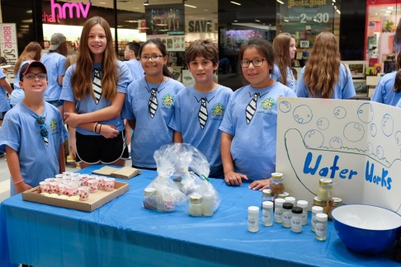 | Wow! CFDCs will get much busier with bright entrepreneurial kids like these. http://bit.ly/2bFSPYz  (pic)
Sept 9 | Promo  2 posts (one French and one English) | CFDCs are in the community and for the community, launching business dreams. Find yours here http://www.oacfdc.com/?Itemid=723  Les SADCs sont dans la communauté, pour la communauté, pour lancer vos entreprises. Trouvez la vôtre. http://www.oacfdc.com/fr/trouvez-une-sadc | CFDCs are in the community and for the community, launching business dreams. Find yours here http://www.oacfdc.com/?Itemid=723  (with pic)  Les SADCs sont dans la communauté pour lancer vos entreprises. Trouvez la vôtre. http://www.oacfdc.com/fr/trouvez-une-sadc (with pic)
Sept 12 | Tips | Some tips for building your website!  http://smallbiztrends.com/2016/08/great-website-tips.html (pick a pic)  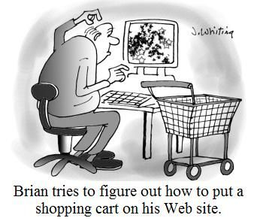 | Some tips for building your website!  http://bit.ly/2bwDV6V  (pic)
Sept 13 | Reach | Here are some habits that demonstrate true entrepreneurial spirit.  http://www.business.com/entrepreneurship/4-habits-you-need-to-perfect-to-become-a-better-entrepreneur/ | Here are some habits that demonstrate true entrepreneurial spirit. http://bit.ly/2bs7pUz (pic)
Sept 14 | News | Come read our latest newsletter! Always worth reading, because there is no wealth like knowledge.  http://www.oacfdc.com/view-current-newsletter  Venez voir notre bulletin actuel! Il n’y a pas de richesses comme la connaissance.  http://www.oacfdc.com/fr/vue-bulletin | Come read our latest newsletter! Always worth reading, because there is no wealth like knowledge.  http://www.oacfdc.com/view-current-newsletter  (with pic)  Venez voir notre bulletin actuel! Il n’y a pas de richesses comme la connaissance.  http://www.oacfdc.com/fr/vue-bulletin (with pic)
Sept 15 | Client profile | (Click link then add description)  https://www.facebook.com/sharer/sharer.php?u=https%3A%2F%2Fwww.facebook.com%2F587802284614727%2Fvideos%2F1128884413839842%2F&ext=1471638053&hash=AeaTlzCleUJxwqlF  His CFDC helped him create seasonal jobs and cash flow the purchase of new inventory.  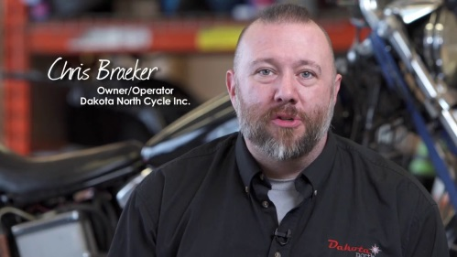 | A CFDC can help create jobs and purchase inventory.  http://bit.ly/2bImUdM  (pic)
Sept 16 | Behind the scenes | A very interesting and innovative business with a lot of job creation, thanks in part to an EODP and Northumberland grant.  http://www.northumberlandtoday.com/2016/08/21/3d-printing-helps-protoplast-compete  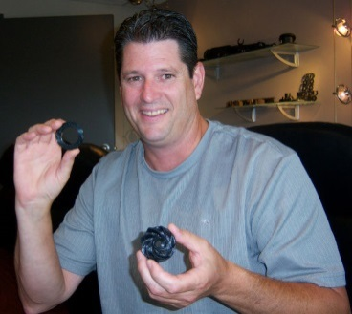 | A very interesting and innovative business with a lot of job creation  http://bit.ly/2bG4qHb (pic)
Sept 19 | Promo | CFDCs assist businesses at all stages of development. Come find yours! http://www.oacfdc.com/?Itemid=723  Les SADCs aident les entreprises avec chaque étape de développement. Venez trouver la vôtre! http://www.oacfdc.com/fr/trouvez-une-sadc | Same thing with pic
Sept 20 | Tips | A lot of great businesses start off as hobbies. Why not give it a shot? https://yourstory.com/2016/08/passion-home-based-business/ | A lot of great businesses start off as hobbies. Why not give it a shot? http://bit.ly/2bmk4we (pic)
Sept 21 | News | We hope to see this trend continue. Small businesses are the backbone of our economy.  http://www.econotimes.com/Canadas-small-business-sentiment-rises-in-August-likely-to-gain-moderately-in-coming-months-268742 | We hope to see this trend continue. Small businesses are the backbone of our economy.  http://bit.ly/2bUWqnh
Sept 22 | Client profile | https://www.facebook.com/sharer/sharer.php?u=https%3A//www.facebook.com/587802284614727/videos/1118633484864935/  (click above, then post what’s below.)  Thanks to the support of their local CFDC, an entrepreneur started a juice bar business, and generated enough loyal customers to employ 3 full time, and 2 part-time staff.  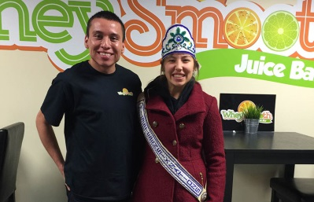 | Their local CFDC helped them start a juice bar and hire 5 employees.  http://bit.ly/2ausNuF  (with pic)
Sept 23 | Reach | He sets a great example, but he took his advice too seriously last month and got into a bicycle accident.  We hope you’re recovering well! | This applies to entrepreneurs everywhere! http://bit.ly/2bgqvwt  (with pic)
Sept 26 | Behind the scenes | A great competition organized by Northumberland CFDC. Investing in innovation is what CFDCs are about. Congrats PinPress! http://www.businesswire.com/news/home/20160809005213/en/PinPress-Wins-N100 Congrats PinPress! Great competition Northumberland CFDC! http://bit.ly/2bbkcLg (pic) | A great competition organized by Northumberland CFDC. Investing in innovation is what CFDCs are about. Congrats PinPress! http://www.businesswire.com/news/home/20160809005213/en/PinPress-Wins-N100 Congrats PinPress! Great competition Northumberland CFDC! http://bit.ly/2bbkcLg (pic)
Sept 27 | Promo | CFDCs grow businesses and communities. Find yours today for support. http://www.oacfdc.com/?Itemid=723  Les SADCs: Des leaders de développement économique rural. Trouvez la vôtre pour le soutien. http://www.oacfdc.com/fr/trouvez-une-sadc | CFDCs are rural economic development leaders. Find yours today for business support. http://www.oacfdc.com/?Itemid=723 pic.twitter.com/tiDPp03QmW  Les SADCs: Des leaders de développement économique rural. Trouvez la vôtre pour le soutien. http://www.oacfdc.com/fr/trouvez-une-sadc  (pic)
Sept 28 | Tips | Keep these tips in mind all you aspiring entrepreneurs!  http://upstart.bizjournals.com/resources/advice/2016/08/08/11-tips-for-succeeding-as-an-entrepreneur.html?page=2 | Keep these tips in mind all you aspiring entrepreneurs! http://bit.ly/2aXmpua  (pic)
Sept 29 | Reach | There is no such thing as failure. Failures are just learning experiences.  https://www.entrepreneur.com/article/240492 | There is no such thing as failure. Failures are just learning experiences. http://entm.ag/1XhH3VH (pic)
Sept 30 | News | Great work NECO! And thank you FedNor!  https://www.baytoday.ca/local-news/putting-northern-ontario-businesses-on-the-global-map-352530  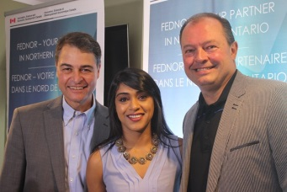 | Great work NECO! And thank you FedNor! http://bit.ly/2aJAJtp  (pic)
 | Behind the scenes | A great competition organized by Northumberland CFDC. Investing in innovation is what CFDCs are about. Congrats PinPress! http://www.businesswire.com/news/home/20160809005213/en/PinPress-Wins-N100 | Congrats PinPress! Great competition Northumberland CFDC! http://bit.ly/2bbkcLg  (pic)

Z:\OACFDC\Marketing & Communications\Social Media Stats\Content Calendar July 2016.docx

LEGEND

CODE | TYPE
Tips | Best practices for business, tips, tricks etc. Can feature board member or client expertise.
News | CFDC media releases, news or updates, upcoming events etc.
Client profile | Share profile of CFDC client
Reach | - Inspirational Posts for entrepreneurs and small business owners  - Ask a question, call for comments.  - Poll to see about behaviour trends/opinions  - Sharing interesting articles or social media content (not by CFDC)
CFDC Behind the scenes | Posts that show what CFDC staff and volunteers and OACFDC are working on, attendance at events/meetings etc – posts that show involvement and caring about the communities in which it serves, things that offer a human face
Promo | Promotional post about the CFDC or OACFDC i.e. We serve xx businesses in the area, come learn more about XX

** CFDC Promotional content should be no greater than 20% of your social media posts. The remainder of your posts should come from the remainder of the categories.

