DATE | CODE | FACEBOOK | TWITTER
Nov 1 | Tips | There are several strategies that can help you reduce the risks you and your customers face when doing business online. Be aware of these risks and take steps to deal with them before they become problems.  http://bit.ly/2eVXKK6  De nombreuses stratégies peuvent vous aider à minimiser les risques auxquels vous et vos clients êtes exposés lorsque vous faites des affaires en ligne. Soyez conscient de ces risques et prenez des mesures pour y faire face avant qu'ils ne deviennent problématiques.  http://bit.ly/2eymk0F | These strategies can help you reduce the risks of doing business online. Be aware & take steps to deal with them http://bit.ly/2eVXKK6  Ces stratégies peuvent vous aider à minimiser les risques lorsque vous faites des affaires en ligne. http://bit.ly/2eymk0F
Nov 2 | News | Come read our latest newsletter! Always worth reading, because there is no wealth like knowledge.  http://www.oacfdc.com/view-current-newsletter  Venez voir notre bulletin actuel! Il n’y a pas de richesses comme la connaissance.  http://www.oacfdc.com/fr/vue-bulletin | Come read our latest newsletter! Always worth reading, because there is no wealth like knowledge.  http://www.oacfdc.com/view-current-newsletter  (with pic)  Venez voir notre bulletin actuel! Il n’y a pas de richesses comme la connaissance.  http://www.oacfdc.com/fr/vue-bulletin (with pic)
Nov 3 | Client profile | The Prince Edward/Lennox and Addington (PELA) Community Futures Development Corporation’s (CFDC) Upper Canada Equity Fund invested $1,350,000 which was matched by the private sector totaling $2.7 million for six new Prince Edward County based technology businesses.  http://www.insidebelleville.com/news-story/6921548--2-7-million-invested-for-tech-firms-in-prince-edward-county/ | Great investment by @pelacfdc $2.7 million invested for tech firms in Prince Edward County http://bit.ly/2elmTNB
Nov 4 | Reach | Use a new, free online business productivity benchmarking tool to see how your business compares to the best in your industry. The results may help you learn where you can improve your performance.  http://ow.ly/1UW5305mKI2  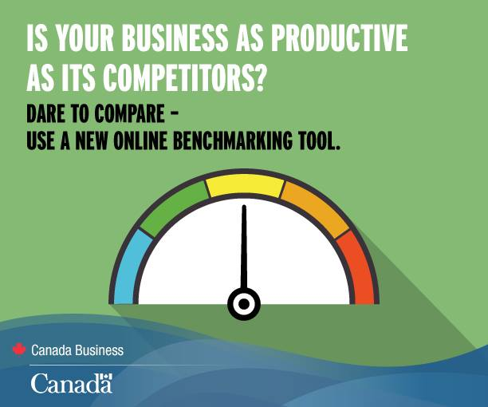  Découvrez le tout premier outil en ligne de comparaison de la productivité au Canada. Les résultats pourraient vous aidez à améliorer votre performance.  http://bit.ly/2eLkIob | Use a new, free online business productivity benchmarking tool to see how your business compares.  http://ow.ly/1UW5305mKI2  Découvrez le tout premier outil en ligne de comparaison de la productivité au Canada. http://bit.ly/2eLkIob
Nov 7 | Behind the scenes | There is a reason you sought this role in the first place, so let’s get back to basics and remember the aspects that encouraged you to start your own business in the first place. Here are the 10 Things You Should Be Thankful For as a Small Business Owner.  http://succeedasyourownboss.com/10-things-thankful-small-business-owner/ | Keep these tips in mind all you aspiring entrepreneurs! http://bit.ly/2aXmpua  (pic)
Nov 8 | Promo | A lot of great businesses start off as hobbies. Why not give it a shot? https://yourstory.com/2016/08/passion-home-based-business/ | A lot of great businesses start off as hobbies. Why not give it a shot? http://bit.ly/2bmk4we (pic)
Nov 9 | Tips | If you want to create content that's worthy of page one rankings, hundreds of social shares and some serious buzz from your customers, it needs to be better than anything else already out there.  http://www.socialmediatoday.com/marketing/how-create-content-10x-better-your-competitors-infographic | How to Create Content 10x Better Than Your Competitors [Infographic] https://shar.es/1xlRMD via @socialmedia2day
Nov 10 | Reach | Businesses in all industries shouldn't underestimate the influence of review sites.  Here are 6 proactive rules for maintaining strong feedback loops, with current customers.  https://www.entrepreneur.com/article/282583 | Here are 6 proactive rules for maintaining strong feedback loops, with current customers.
Nov 14 | News | Ontario Trillium Foundation Announces New Granting Application Deadlines for 2017.  https://shar.es/1IWFhw  La Fondation Trillium de l’Ontario annonce de nouvelles dates subventionnaires pour 2017  http://bit.ly/1HfOzct | Ontario Trillium Foundation Announces New Granting Application Deadlines for 2017 https://shar.es/1IWFhw  La Fondation Trillium de l’Ontario annonce de nouvelles dates subventionnaires pour 2017 http://bit.ly/1HfOzct
Nov 15 | Client profile | Renfrew County CFDC helps support company that builds the “Cadillac of cabinets”  http://www.thedailyobserver.ca/2016/09/01/ki-canada-launches-new-product  (pic in link) | Renfrew County CFDC helps support company that builds the “Cadillac of cabinets”  http://bit.ly/2czpxKP  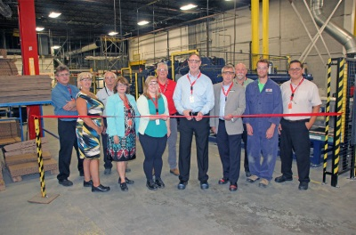
Nov 16 | Behind the scenes | Are you a small business owner and would like to share your opinions with the Canada Revenue Agency?  Now is your chance! The CRA would like to get the opinion of the owners of SMEs, the accountants and the levels of books on the way in which it can improve its services and programs to better satisfy their operational needs.  Discover how to participate in person or online at http://www.canadabusiness.ca/eng/blog/entry/5558/ | Share your views on how the Canada Revenue Agency can serve you better. More info here: http://ow.ly/hurX304hV3w
Nov 17 | Promo | CFDCs grow businesses and communities. Find the support you need at www.cfontario.ca  Les SADCs: Des leaders de développement économique rural. Trouvez la vôtre pour le soutien. www.ontsadc.com | CFDCs grow businesses and communities. Find the support you need at www.cfontario.ca  Les SADCs: Des leaders de développement économique rural. Trouvez la vôtre pour le soutien. www.ontsadc.com  (pic)
Nov 18 | Tips | For many young people, millennial is something of a dirty word. But the truth is that millennials get a bad rap. They may go about things differently, but today’s young people are making an impact on the world around them.  http://bit.ly/2cxXmAP | Young entrepreneurs and the myth of the lazy millennial http://fw.to/YAwGq7C (with pic)
Nov 21 | News | The Rural Employment Initiative is collaboration between Ontario’s 60 Community Futures Development Corporations and the Newcomer Centre of Peel and funded by the Ontario Trillium Foundation.  http://www.producer.com/2016/10/immigration-programs-target-rural-canada/ | Most newcomers to Canada settle in cities, but the Rural Employment Initiative is changing that. http://bit.ly/2ff68oR (with pic)
Nov 22 | Client profile | If you are in the market for a franchise, there are literally thousands to choose from.  Here are five questions a franchise should ask potential partners.  https://www.entrepreneur.com/article/281303 | 5 Questions You Need to Answer Before Choosing a Franchise http://entm.ag/2c4RHgx with pic
Nov 23 | Reach | All CFDC financing decisions are made at the community level by a dedicated local board of directors. http://www.oacfdc.com/member-office-maps | All CFDC financing decisions are made at the community level by a dedicated local board of directors. http://www.oacfdc.com/member-office-maps
Nov 24 | Behind the scenes | Working on community projects is a large part of what CFDCs do http://www.insideottawavalley.com/news-story/6907990-new-downtown-kemptville-signs-designed-to-direct-traffic-from-county-road-43/  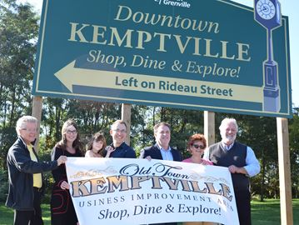 | Working on community projects is a large part of what CFDCs do http://bit.ly/2eUVQ9l
Nov 25 | Promo | CFDCs have a proven track record of helping businesses grow. Let us show you how! http://www.oacfdc.com/member-office-maps  Les SADCs aident agrandir les entreprises. Demandez-nous comment! http://www.oacfdc.com/fr/cfdc-area-maps-fr | Same thing with pic
Nov 28 | Tips | Succession planning- Find the right strategy for selling your business or handing it over to someone else, whether it be an employee, a family member, a friend or another entrepreneur. http://bit.ly/2e6isSB | Succession planning- Find the right strategy for selling your business or handing it over to someone else http://bit.ly/2e6isSB
Nov 29 | Reach | How many SMEs are there in Canada? Here is a hint…they make up 97.9% of all businesses in Canada!  https://www.ic.gc.ca/eic/site/061.nsf/eng/03021.html  Combien de PME y a-t-il au Canada ? Voici un indice... ils composent 97,9 % de toutes les entreprises au Canada ! https://www.ic.gc.ca/eic/site/061.nsf/fra/03021.html | How many SMEs are there in Canada? Here is a hint…they make up 97.9% of all businesses in Canada! http://bit.ly/2dYNsIN  Combien de PME y a-t-il au Canada ? Voici un indice... ils composent 97,9 % de toutes les entreprises au Canada ! http://bit.ly/2eV08gX
Nov 30 | News | A celebration of 10 new jobs in Chesterville- with the help of @CCCFDC http://bit.ly/2fo4lhj | A celebration of 10 new jobs in Chesterville- with the help of @CCCFDC http://bit.ly/2fo4lhj

LEGEND

CODE | TYPE
Tips | Best practices for business, tips, tricks etc. Can feature board member or client expertise.
News | CFDC media releases, news or updates, upcoming events etc.
Client profile | Share profile of CFDC client
Reach | - Inspirational Posts for entrepreneurs and small business owners  - Ask a question, call for comments.  - Poll to see about behaviour trends/opinions  - Sharing interesting articles or social media content (not by CFDC)
CFDC Behind the scenes | Posts that show what CFDC staff and volunteers and OACFDC are working on, attendance at events/meetings etc – posts that show involvement and caring about the communities in which it serves, things that offer a human face
Promo | Promotional post about the CFDC or OACFDC i.e. We serve xx businesses in the area, come learn more about XX

** CFDC Promotional content should be no greater than 20% of your social media posts. The remainder of your posts should come from the remainder of the categories.

