DATE | CODE | FACEBOOK | TWITTER
April 3 | Tips | CFDCs can help you work through this process but these tips will help you be ready for that first conversation with your CF professional.  http://succeedasyourownboss.com/how-to-develop-your-business-idea/ | CFDCs can help you work through this process- these tips will help get you ready http://bit.ly/1mTuK5h
April 4 | News  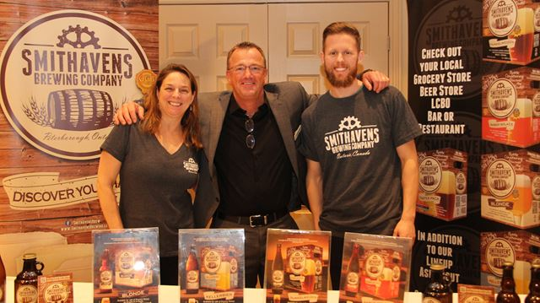 | Perfect reason for #CommunityFuturesPeterborough to celebrate! To-date the EODP program has invested over $80 million in 7,600 business and community development projects. http://bit.ly/2njGqmw | @CF_Peterborough celebrates the EODP program- invested over $80 million in 7,600 business and community projects. http://bit.ly/2njGqmw
April 5 | Client profile  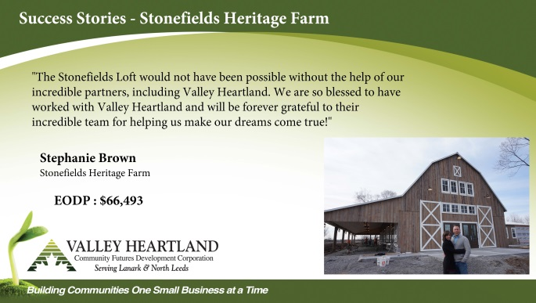 | Our clients’ business success is how we measure our success http://stonefieldsweddings.com/ | Our clients’ business success is how we measure our success  http://stonefieldsweddings.com/
April 6 | Reach | What to do with your businesses’ social media accounts that are digital zombies – they’re not dead, but they’re certainly not alive https://tgam.ca/2hU2bmp | Are your businesses’ social media accounts digital zombies – they’re not dead, but they’re certainly not alive https://tgam.ca/2hU2bmp
April 10 | Behind the scenes | The Win this Space competition was the winner of our CED Award of Excellence for 2016. A new contest to win free business space in downtown Pembroke is now up and running. http://www.thedailyobserver.ca/2017/03/08/win-this-space-launches | The 2016 CED Award of Excellence winner -Win this Space competition for business space is available in Pembroke http://bit.ly/2mp9TGR
April 11 | Promo | CFDCs are rural economic development leaders. Find yours today for business financing and planning. https://www.cfontario.ca/find-a-local-cfdc  Les SADCs sont des leaders de développement économique rural. Trouvez la vôtre pour le soutien. https://www.cfontario.ca/fr/trouvez-une-sadc | CFDCs are rural economic development leaders. Find yours today for business support. http://bit.ly/2js6XJh  Les SADCs: Des leaders de développement économique rural. Trouvez la vôtre pour le soutien http://bit.ly/2kbUGvP
April 12 | Tips  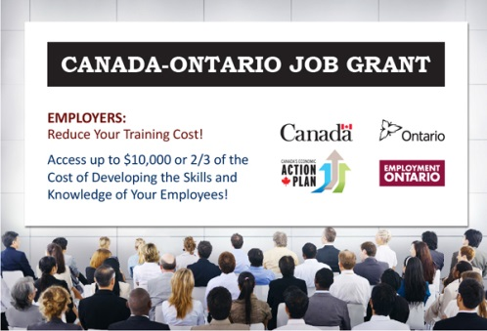 | If you're an employer looking to help pay for the training your people need or you want training for yourself- this program can help. http://bit.ly/1uvQjM8 | If you're an employer looking to help pay for staff training or you want training for yourself- read on http://bit.ly/1uvQjM8
April 13 | Reach  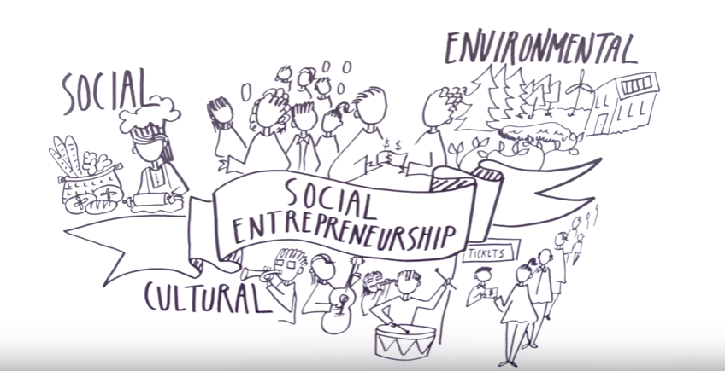 | So how exactly is a Social Enterprise different??  https://www.youtube.com/watch?v=9_g5RqwW51I | So how exactly is a Social Enterprise different??  https://www.youtube.com/watch?v=9_g5RqwW51I
April 18 | News | Come read our latest newsletter! Always worth reading, and the more you know, the farther you’ll go. https://www.cfontario.ca/view-current-newsletter  Venez voir notre bulletin actuel! La connaissance est importante et qui n’avance pas, recule. https://www.cfontario.ca/fr/vue-bulletin | Come read our latest newsletter! Always worth reading, and the more you know, the farther you’ll go. https://www.cfontario.ca/view-current-newsletter  Venez voir notre bulletin actuel! La connaissance est importante et qui n’avance pas, recule. https://www.cfontario.ca/fr/vue-bulletin
April 19 | Client profile | Social Enterprises making a difference…. Stories for the common good http://bit.ly/2nAj6h1 | Social Enterprises making a difference…. Stories for the common good http://bit.ly/2nAj6h1
April 20 | Behind the scenes | Great local TV coverage of @CommunityFuturesOxford and the Oxford Student Competition http://rogerstv.com/show?lid=12&rid=15&sid=6397&gid=272984 | Great local TV coverage of @OxfordCFDCh and the Oxford Student Competition http://rogerstv.com/show?lid=12&rid=15&sid=6397&gid=272984
April 21 | Promo | Do you have a business idea and need help making it a reality? Reach out today at 1-888-633-2326 or find your nearest office at https://www.cfontario.ca/find-a-local-cfdc  Avez-vous une idée d’entreprise et avez besoin d’aide pour la réaliser ? Contactez-nous au 1-888-633-2326 ou trouvez le bureau le plus proche au https://www.cfontario.ca/fr/trouvez-une-sadc | Do you have a business idea and need help making it a reality? Reach out today at 1-888-633-2326 or e at http://bit.ly/2js6XJh  Avez-vous une idée d’entreprise et avez besoin d’aide pour la réaliser ? Contactez-nous au 1-888-633-2326 ou http://bit.ly/2kbUGvP
April 24 | Tips | You want to start your own #business, but have you done your homework? http://buff.ly/2mTjyJg | You want to start your own #business, but have you done your homework? http://buff.ly/2mTjyJg
April 25 | News  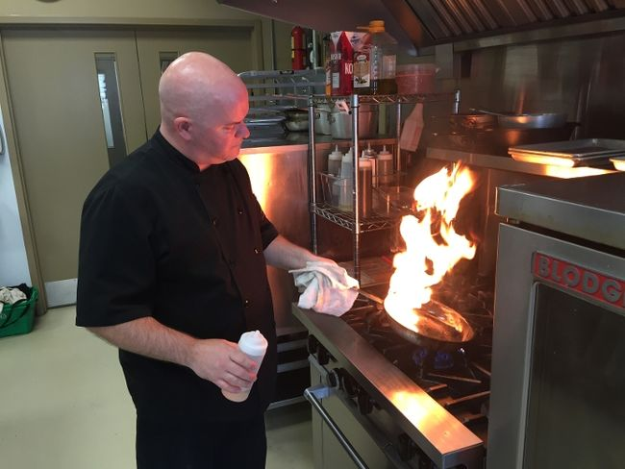 | @ElginBusinessResourceCentre is celebrating 30 years of helping businesses succeed in Elgin County! Congrats http://bit.ly/2nLskap | @ebrc is celebrating 30 years of helping businesses succeed in Elgin County! Congrats http://bit.ly/2nLskap
April 26 | Client profile  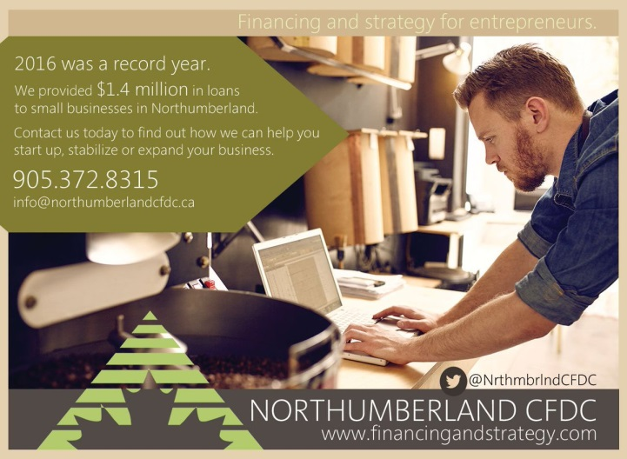 | Your rural business success is our success! @NorthumberlandCFDC | Your rural business success is our success! @NrthmbrlandCFDC
April 27 | Reach | If this is you- come talk to us… we will help https://www.cfontario.ca/find-a-local-cfdc | If this is you- come talk to us… we will help https://www.cfontario.ca/find-a-local-cfdc
April 28 | Tips | You only have one chance to make a first impression on a new customer. Stop making these mistakes now with your new customers in order to close more deals than ever before. http://on.inc.com/2n3jULC | 1st impressions matter- stop making these mistakes with your new customers http://on.inc.com/2n3jULC
CODE | TYPE
Tips | Best practices for business, tips, tricks etc. Can feature board member or client expertise.
News | CFDC media releases, news or updates, upcoming events etc.
Client profile | Share profile of CFDC client
Reach | - Inspirational Posts for entrepreneurs and small business owners  - Ask a question, call for comments.  - Poll to see about behaviour trends/opinions  - Sharing interesting articles or social media content (not by CFDC)
CFDC Behind the scenes | Posts that show what CFDC staff and volunteers and OACFDC are working on, attendance at events/meetings etc – posts that show involvement and caring about the communities in which it serves, things that offer a human face
Promo | Promotional post about the CFDC or OACFDC i.e. We serve xx businesses in the area, come learn more about XX

