
OACFDC Entrepreneur of the Year
Award 2016

Recognizing an Outstanding Entrepreneur

Outstanding Entrepreneur Award
A CFDC loan client which illustrates innovation in business practice, builds on the resources at hand, responds to changes, challenges and opportunities and demonstrates positive employment and economic outcomes in the community.

Nominations
Each CFDC completes one nomination form per nominee. The CFDC then submits nomination form by email (supplementary materials submitted electronically must be properly labeled, and in Word, Excel or PDF format).
All entries must be received by 4 :00 pm, Friday June 3rd, 2016.

Selection process
Two independent judges, with no connection to the OACFDC or the Community Futures Program in Ontario, will review the nominations and provide their selection to the OACFDC. Submission of a nomination form entitles the OACFDC to disclose nominees’ names, business information and photos and video for promotion and marketing purposes. One winner will be determined.

Winning Entry
The successful nominee will receive recognition at a special banquet and awards ceremony at the OACFDC’s Annual Conference. A video presentation about the winning entrepreneur’s business will be prepared for Awards Ceremony which will take place on Tuesday September 13th, at the Clarion Inn Lakeside in Kenora.

The winner will receive a crystal trophy as a memento of the occasion and a cash prize of $350. During the Awards Ceremony, a video presentation will be shown about the business, with the winner receiving a copy on DVD. Transportation for two and one hotel room for one night will also be provided to the winner.

Members’ Choice Award
A brief description of each nomination for the Entrepreneur of the Year will be posted on the OACFDC website. OACFDC members will be able to go online and vote for their favourite. The Member’s Choice Award winner will also be announced during our Awards Gala Dinner.

Nomination Instructions

√ Checklist:

❑ Include local media contact information (email addresses) – for newspaper, television, radio or any specific websites or social media (Word or Excel format).

❑ Answer all questions on the attached nomination form. – Please be as brief as possible.

❑ Submissions to be e-mailed to Brenda LaGrandeur: blagrandeur@oacfdc.com (Electronic files must be properly labeled, and in Word, Excel or PDF format) Scan and email any supplementary information.

❑ If material cannot be scanned, mail three (3) labeled, paper copies of any supplementary materials (One copy for the OACFDC and one copy for each of two judges.)

Must be received by 4 :00 pm on Friday June 3rd, 2016!
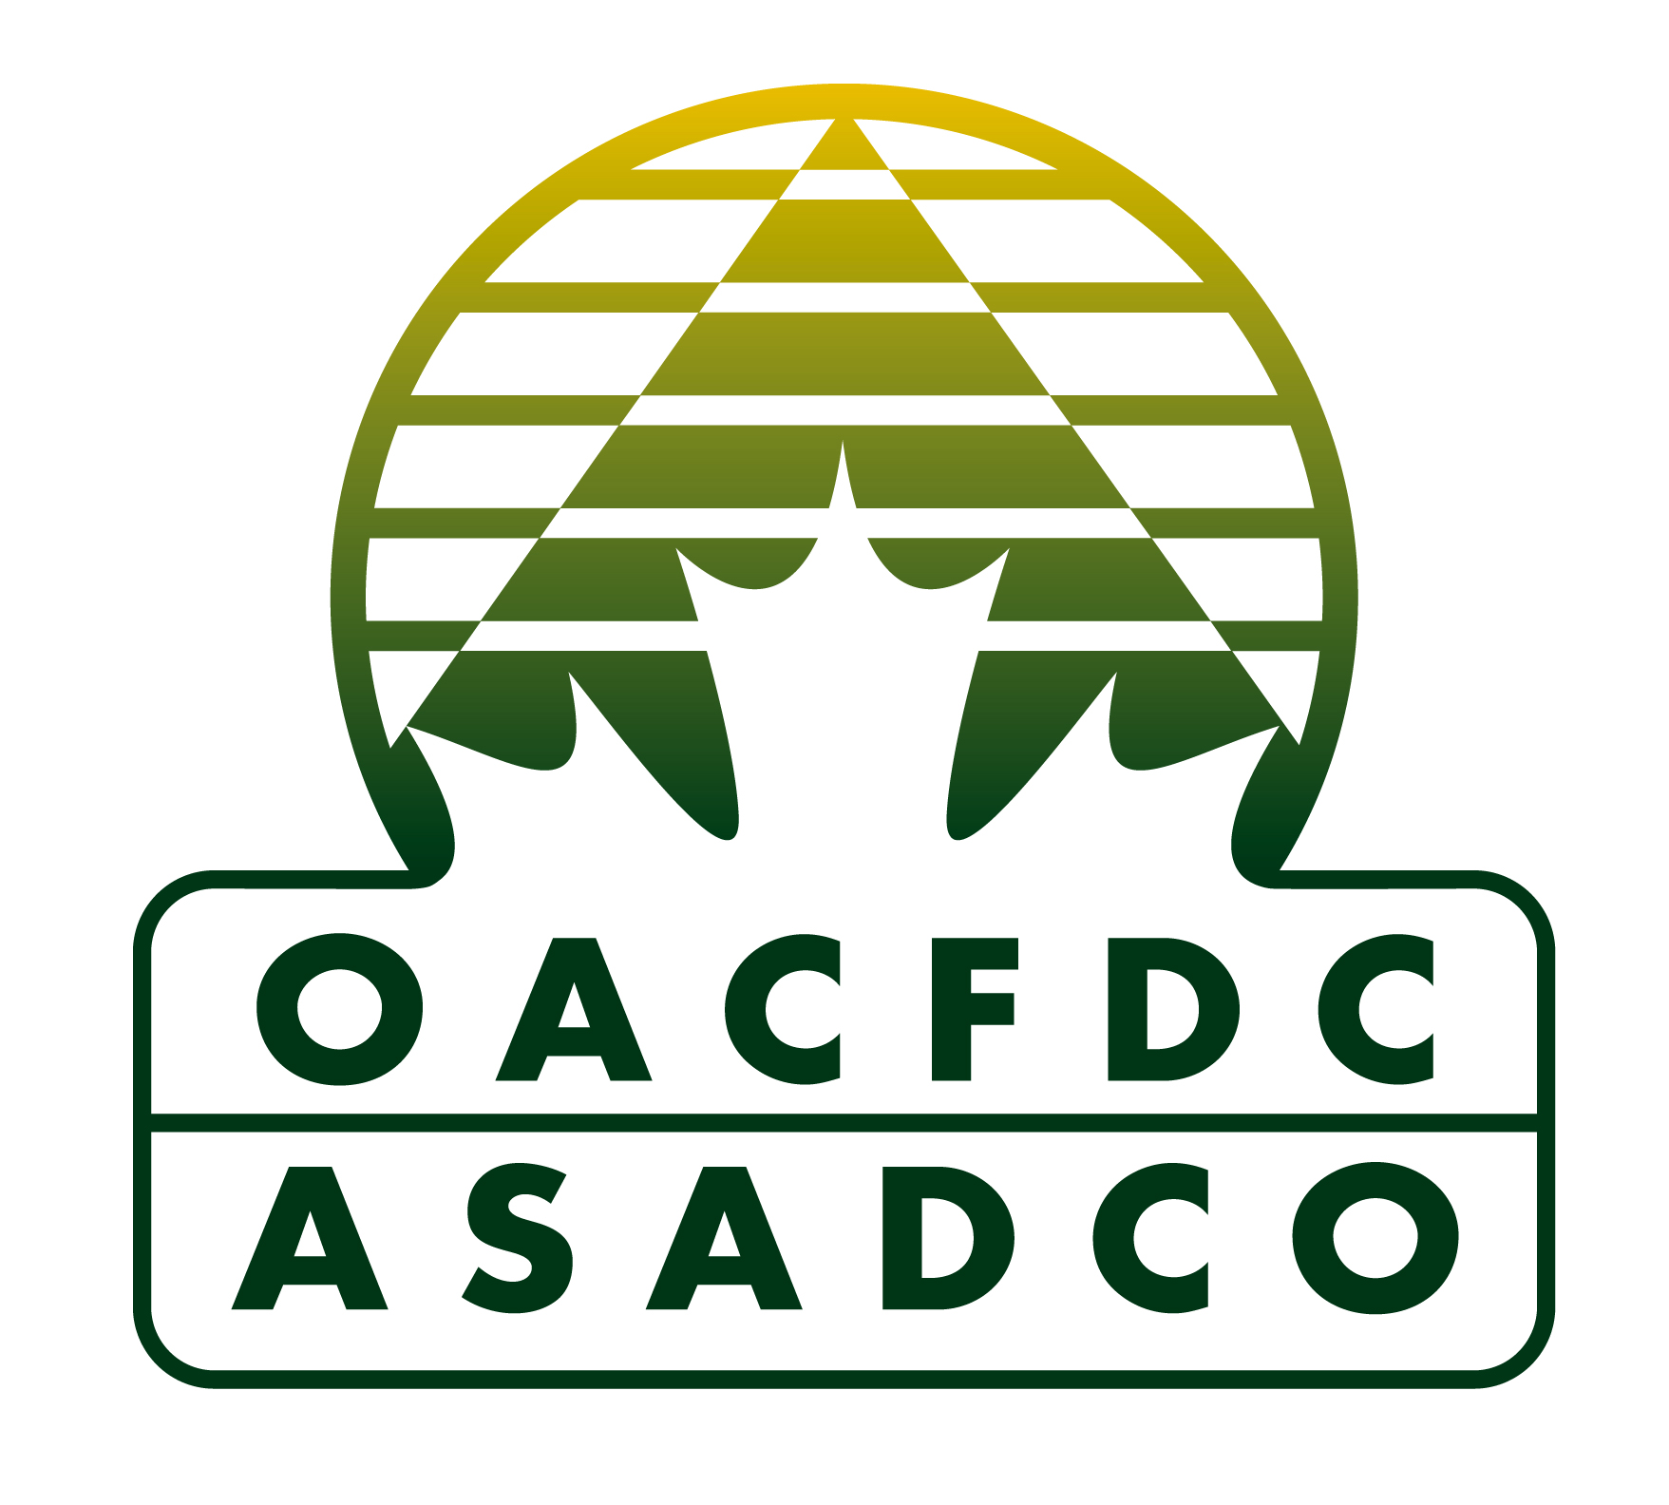



Ontario Association of Community Futures Development Corporations Inc. (OACFDC)
300 South Edgeware Road, St. Thomas, ON N5P 4L1
If you have any questions, contact Brenda LaGrandeur
Phone: 888-633-2326 ext. 125 or E-mail: blagrandeur@oacfdc.com

OACFDC Entrepreneur of the Year Award 2016

You may answer the questions in the table below, or in a new file..

Nomination Chart | Please complete each line with point form or bullets
Business NAME
Name of Business owner
Mailing address
Telephone number
Email address
Name of NOMINATOR
Nominator’s CFDC
Nominator’s phone number
Nominator’s email address
Note: In consideration of our volunteer judges, please submit brief items that clearly address the goals of the award.
- Briefly describe the entrepreneur.
- Describe how the businesses’ activities demonstrate excellence.
- How many people have benefitted from this business and how?
- What are the long-term benefits for the rural community?
- In what year did the business open?
- In what year did the entrepreneur receive a CFDC loan?
- Are there supplementary materials that can help to illustrate the impact of this nominee?
Provide a list of the supplementary materials, and describe the relevance of each item. Submit electronically (must be properly labeled, and in Word, Excel or Adobe PDF format) or mail us three (3) labeled paper copies with your nomination.
- I give permission for information in this nomination paper to be posted online for the Members’ Choice Award. | Name and Title of person giving permission:
Ontario Association of Community Futures Development Corporations Inc. (OACFDC)
300 South Edgeware Road, St. Thomas, ON N5P 4L1
If you have any questions, contact Brenda LaGrandeur
Phone: 888-633-2326 ext. 125 or E-mail: blagrandeur@oacfdc.com

GOOD LUCK!

