
CFDC
Awards of Excellence
2016

Recognizing Ontario’s Outstanding
Community Futures Development Corporations

This year’s Awards of Excellence will recognize CFDCs in each of the following two categories:

1) Collaboration on Innovation

2) Community Economic Development Project

Criteria

1) Must be relevant and accountable to the goals of the CFDC.

2) Should be transferable to other CFDCs.

3) Must have a proven track record of at least one year.

4) Must have a measurable impact (job creation, innovation, people involved)

Nomination process
Each CFDC completes one nomination form per nominee. The CFDC then submits nomination form by email (supplementary materials submitted electronically must be properly labeled, and in Word, Excel or PDF format). All entries must be received by 4:00 pm, Friday June 3, 2016.

Selection process
Two independent judges, with no connection to the OACFDC or the Community Futures Program in Ontario, will review the nominations and provide their selection to the OACFDC. Submission of an entry form entitles the OACFDC to disclose nominees’ names, project information and videos and photos for promotion and marketing purposes.

The successful nominee(s) will be recognized at the OACFDC Annual Conference, during the Awards Gala Dinner, to be held Tuesday, September 13th, 2016 at the Clarion Lakeside Inn, in Kenora. A video presentation will be shown about the project or initiative, with the winning CFDC receiving a copy on DVD. As well, they will receive an attractive crystal trophy as a memento of the occasion.

Members’ Choice Award
A brief description of each nomination for the Awards of Excellence will be posted on the OACFDC website. OACFDC members will be able to go online and vote for their favourite. The Member’s Choice Award winner will also be announced during our Awards Gala Dinner.

Nomination Instructions

√ Checklist:

❑ Include a list of your local media’s contact information (email addresses) – for newspaper, television, radio or any specific websites or social media (Word or Excel format).

❑ Answer all questions on the attached nomination form – Please be as brief as possible.

❑ Submissions to be e-mailed to Brenda LaGrandeur: blagrandeur@oacfdc.com (Electronic files must be properly labeled, and in Word, Excel or PDF format). Scan and email any supplementary information.

❑ If material cannot be scanned, mail three (3) labeled, paper copies of any supplementary materials (One copy for the OACFDC and one copy for each of two judges.)

Must be received by 4 :00 pm on Friday June 3rd, 2016!
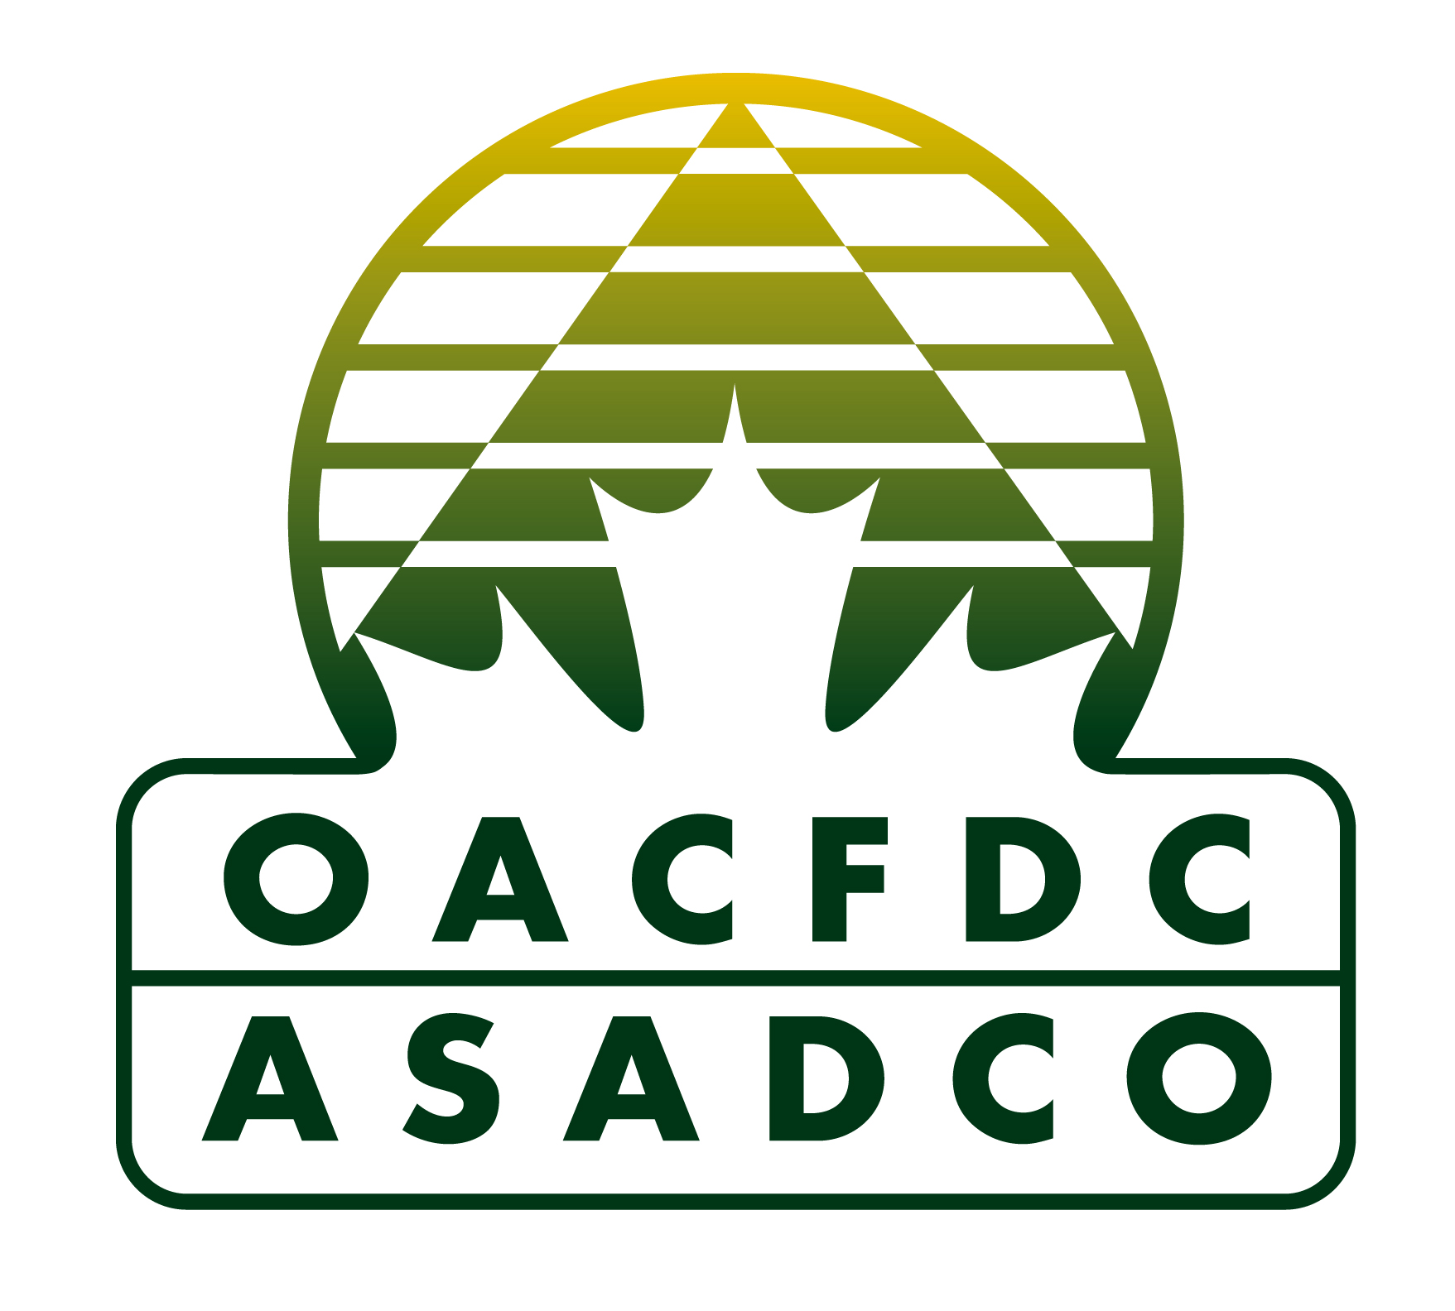



Ontario Association of Community Futures Development Corporations Inc. (OACFDC)
300 South Edgeware Road, St. Thomas, ON N5P 4L1
If you have any questions, contact Brenda LaGrandeur
Phone: 888-633-2326 ext. 125 or E-mail: blagrandeur@oacfdc.com

CFDC Awards of Excellence 2016

You may answer the questions in the table below, or in a new file.

Nomination Chart | Please complete each line with point form or bullets
Award Category of Nomination (Circle One) | Innovation or CED Project
Initiative or Project NAME
Name of the contact person
Mailing address
Telephone number
Email address
Note: In consideration of our volunteer judges, please submit brief items that clearly address the goals of the award.
- Briefly describe the initiative or project.

- Describe how the project's activities demonstrate excellence.
- How many people have benefited from this initiative and how?
- What are the long-term benefits for the rural community?
- In what year did the initiative take place?

- Are there supplementary materials that help to illustrate the impact of this nominee?
Provide a list of the supplementary materials, and describe the relevance of each item. Submit electronically (must be properly labeled, and in Word, Excel or Adobe PDF format) or mail us three (3) labeled paper copies with your nomination.
- I give permission for information in this nomination paper to be posted online for the Members’ Choice Award. | Name and Title of person giving permission:
Ontario Association of Community Futures Development Corporations Inc. (OACFDC)
300 South Edgeware Road, St. Thomas, ON N5P 4L1
If you have any questions, contact Brenda LaGrandeur
Phone: 888-633-2326 ext. 125 or E-mail: blagrandeur@oacfdc.com

GOOD LUCK!

