DATE | CODE | FACEBOOK | TWITTER
Dec 1 | Tips | Are you being asked by friends and family for discounts or deals from your new business? This might not be a cycle you want to start.  http://careerpreneur.ca/2016/07/31/dont-give-away-your-expertise-for-free/ | Don't Give Away Your Expertise For Free! http://careerpreneur.ca/2016/07/31/dont-give-away-your-expertise-for-free/ via @career_prenuer
Dec 2 | News | A celebration of 10 new jobs in Chesterville- with the help of @CCCFDC http://bit.ly/2fo4lhj  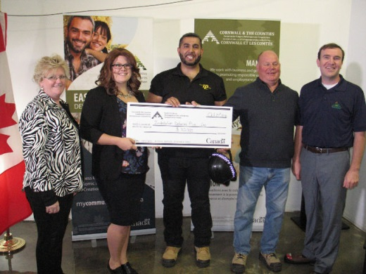 | A celebration of 10 new jobs in Chesterville- with the help of @CCCFDC http://bit.ly/2fo4lhj
Dec 5 | Client profile | @ValleyHeartland CFDC’s client creates an idyllic setting for weddings and other special events. @Stonefields Heritage Farm promises many happy ever afters. http://ottawacitizen.com/life/style/whats-old-is-new-again-2 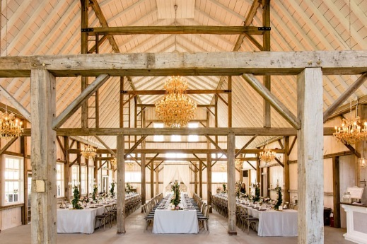 | @ValleyHeartland CFDC’s client creates an idyllic setting for happy ever after events #Stonefields Heritage Farm http://bit.ly/2g8G8fn
Dec 6 | Reach | How many SMEs are there in Canada? Here is a hint…they make up 97.9% of all businesses in Canada!  https://www.ic.gc.ca/eic/site/061.nsf/eng/03021.html  Combien de PME y a-t-il au Canada ? Voici un indice... ils composent 97,9 % de toutes les entreprises au Canada ! https://www.ic.gc.ca/eic/site/061.nsf/fra/03021.html | How many SMEs are there in Canada? Here is a hint…they make up 97.9% of all businesses in Canada! http://bit.ly/2dYNsIN  Combien de PME y a-t-il au Canada ? Voici un indice... ils composent 97,9 % de toutes les entreprises au Canada ! http://bit.ly/2eV08gX
Dec 7 | Behind the scenes | Developed in 2012 by the Northumberland CFDC in partnership with their Regional Innovation Centre, Spark Centre, the N100 Startup Competition is designed to accelerate high growth potential startups with a grand prize of $100,000.  http://n100.ca/ | Developed by the @NrthmbrlndCFDC, @N100startups 's $100k prize aims to accelerates innovative startup growth http://n100.ca/
Dec 8 | Promo | Are you a Rural Entrepreneur from Ontario looking for help to get your business off the ground? Check out the Community Futures Program and find the office nearest to you http://www.oacfdc.com/member-office-maps  Êtes-vous un entrepreneur rural de l'Ontario qui cherche de l'aide à décoller votre entreprise ? Découvrez le programme du Développement des collectivités et trouver le bureau le plus proche de vous http://www.oacfdc.com/fr/cfdc-area-maps-fr | Looking to get your business off the ground in rural ON? Think Community Futures and find the closest office http://bit.ly/2f9cKkk  Vous cherchez à décoller votre entreprise rurale en Ontario ? Penser aux SADC et trouver le bureau le plus proche http://bit.ly/2eYhcVs
Dec 9 | Tips | Entrepreneurs are glass half-full people. They can find opportunity in the bleakest situations. They can turn failure into success. And they never stop dreaming. https://www.entrepreneur.com/article/284712  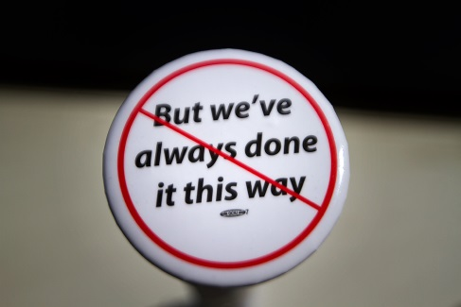 | Entrepreneurs are glass half-full people. What makes great entrepreneurs think differently? http://bit.ly/2gaLplN
Dec 12 | Reach | There are many benefits to relying on a cloud-based system but with it also comes a fear of data safety. Here are some info to help manage your nonprofit on the Cloud  https://www.techsoupcanada.ca/en/community/blog/is-my-data-safe-managing-your-nonprofit-on-the-cloud | Is My Data Safe? Managing your Nonprofit on the Cloud | TechSoup Canada - http://go.shr.lc/2exRCYL via @Shareaholic
Dec 13 | News | Come read our latest newsletter! Always worth reading, because there is no wealth like knowledge.  http://www.oacfdc.com/view-current-newsletter  Venez voir notre bulletin actuel! Il n’y a pas de richesses comme la connaissance.  http://www.oacfdc.com/fr/vue-bulletin | Come read our latest newsletter! Always worth reading, because there is no wealth like knowledge.  http://www.oacfdc.com/view-current-newsletter  (with pic)  Venez voir notre bulletin actuel! Il n’y a pas de richesses comme la connaissance.  http://www.oacfdc.com/fr/vue-bulletin (with pic)
Dec 14 | Client profile | Looking for delicious and small scale hand crafted charcuterie and cured smoked meats this holiday season? @Frontenaccfdc’s client @SeedToSausage ships Ontario-wide. http://seedtosausage.ca/ | Delicious artisan crafted cured smoked meats -shipped Ontario-wide @Frontenaccfdc’s client @SeedToSausage http://seedtosausage.ca/
Dec 15 | Behind the scenes | This holiday season; be sure to remember small businesses!  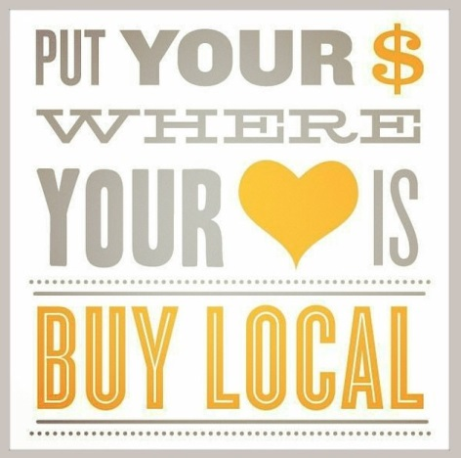 | This holiday season; be sure to remember small businesses!
Dec 16 | Promo | In need of financing or assistance to help grow your business? CFDCs can help; we offer flexible financing and programs to suit your needs. Visit us online http://www.oacfdc.com/member-office-maps or phone 1-888-633-2326  Vous avez besoin de financement ou d'assistance pour agrandir votre entreprise? Les SADC peuvent vous aidez. Trouvez votre bureau http://www.oacfdc.com/fr/cfdc-area-maps-fr ou appelez nous au 1-888-633-2326 | In need of financing or assistance to help grow your business? CFDCs can help http://bit.ly/2f9cKkk or call 1-888-633-2326  Vous avez besoin de financement ou d'assistance pour agrandir votre entreprise? Les SADC peuvent vous aidez http://bit.ly/2f9cKkk
Dec 19 | Tips | Tech Soup Canada provides charities and nonprofits access to donated technology products, learning content, and community support. Are you eligible? www.TechSoupCanada.ca | @techsoupcanada provides charities and nonprofits access to donated technology products. Are you eligible? www.TechSoupCanada.ca
Dec 20 | News | These tools will help you choose the financial products and services that suit your needs. http://www.fcac-acfc.gc.ca/Eng/resources/toolsCalculators/Pages/home-accueil.aspx  Ces outils interactifs peuvent vous aidez à choisir les produits et services financiers qui répondent à vos besoins. http://bit.ly/2fzTnBE | These tools will help you choose the financial products and services that suit your needs http://bit.ly/2frQ5Ta  Ces outils interactifs peuvent vous aidez à choisir les produits et services financiers qui répondent à vos besoins. http://bit.ly/2fzTnBE
Dec 21 | Client profile | @CenturyChocolates is owned and operated by the husband and wife team of Ryan & Krista Harris. The story of their growing business venture is one of humble beginnings and a love of chocolate.  They were the 2016 winner of the Elgin Business Resource Centre Business Plan competition @ebrc http://bit.ly/2dSTyLb | @CenturyChocolates were the 2016 winner of the Elgin Business Resource Centre Business Plan competition @ebrc http://bit.ly/2dSTyLb
Dec 22 | Reach | My business provides me with an income that I am comfortable with. I don’t work long hours and I like that.  http://www.theglobeandmail.com/report-on-business/small-business/sb-growth/i-dont-want-to-grow-my-business-am-i-missing-something/article32148586/ | My business provides me with an income that I am comfortable with. I don’t work long hours and I like that. https://tgam.ca/2dRPzwe
 | Behind the scenes
 | Promo
 | Tips
 | Reach
 | News

LEGEND

CODE | TYPE
Tips | Best practices for business, tips, tricks etc. Can feature board member or client expertise.
News | CFDC media releases, news or updates, upcoming events etc.
Client profile | Share profile of CFDC client
Reach | - Inspirational Posts for entrepreneurs and small business owners  - Ask a question, call for comments.  - Poll to see about behaviour trends/opinions  - Sharing interesting articles or social media content (not by CFDC)
CFDC Behind the scenes | Posts that show what CFDC staff and volunteers and OACFDC are working on, attendance at events/meetings etc – posts that show involvement and caring about the communities in which it serves, things that offer a human face
Promo | Promotional post about the CFDC or OACFDC i.e. We serve xx businesses in the area, come learn more about XX

** CFDC Promotional content should be no greater than 20% of your social media posts. The remainder of your posts should come from the remainder of the categories.

